Skaters and Parents Handbook


Welcome to another exciting skating season!

2026-2027

We want to ensure you stay informed with the latest updates and information. Please download the TeamReach app to access current announcements, schedules, and important communications. Access Code: Sk8TFSC1
If you have any questions, please feel free to contact us through the TeamReach app.

Tilbury Figure Skating Club Board Members

The Tilbury Skating Club would like to introduce you to our 2026-2027 Board Members.
President:
Vice President
Treasurer:
Secretary:
Test Chairpersons:
Parent Liaisons:
Canskate/Learn to Skate/Star 1
Star 2-3
Star 4-Gold
Program Assistant Rep:
Bingo Chairperson:
Public Relations/Advertising:
Carnival Chairperson:
Music Chairperson:
Coaches Representative:
Ice Captain:

Randy Borean
Sharron Skipper
Krystal Ducharme
Rachelle Flynn
Jacqui Strong & Nancy Borean

Sarina Regnier-Ryan
Nicole Sarafin
Kristy O’Neill
Deb Daigneau
Sharron Skipper & Krystal Ducharme
Renée Regnier
Renee Regnier
All Coaches
Deb Daigneau
Jensen Bowden
Board members are available during regular skating session times. Feel free to approach us if you have any concerns.
TFSC BOARD MEETINGS
Monthly Board Meeting dates will be posted on the Club’s social media page and bulletin board. Parents are encouraged to attend these meetings. If you have any questions, concerns, or suggestions for Board consideration, please submit them in writing. Time will be allocated during the meeting to review and discuss submitted items. While a decision may not be made at that meeting, all matters will be given careful consideration, and the Board will communicate its decision as soon as possible.
MEET OUR 2026-2027 PROFESSIONAL COACHING STAFF

Deb Daigneau
Jensen Bowden
Kelly Dunwoody
Krislyn Malott-Imeson
Chelsey Malott
Jessica Buxton
Valerie Thrower
Olivia Johnson
Charlotte Johnson
Joelynn Strong
Josie Borean
Mia Bella Ingratta
Kayla Flynn

All coaches are certified in First Aid and CPR.
Club Professional Coaches offer private and semi-private lessons. Individual instruction is recommended for skaters seeking to advance through the program more quickly. Lessons may be arranged by contacting coaches directly.

For session or coaching-related inquiries, please email tilburyfsc.coach@gmail.com or write to:
Tilbury Figure Skating Club P.O. Box 274, Tilbury, Ontario N0P 2L0

General Information
Dressing Rooms: Please use the assigned dressing rooms indicated on the TV monitor above the dressing room doors. Skates should not be put on or removed in the arena lobby.
Attendance: Skaters should arrive 10 minutes prior to the start of their session to allow time for check-in, orientation, off-ice warm-up activities, and receipt of name tags (if required).

TFSC SKATING PROGRAMS

LEARN TO SKATE
When we say on-ice, that is exactly what it means. The very first thing our skaters will learn is to feel comfortable with their new ice surroundings. Our first month is suited just for touching ice, body rolling from one side of the ice level to the other. Crawling skills are important and practising the art of falling and getting up. When these skills are mastered SKATING BEGINS.

CANSKATE - Skating Starts Here
CanSkate is Skate Canada’s premier learn-to-skate program for beginners of all ages, including children, adults, and athletes with disabilities (AWAD). Whether your goal is figure skating, hockey, ringette, speed skating, or recreational skating, CanSkate program focuses on developing balance, control, and agility through structured and engaging instruction. Skaters build essential skills in a safe, supportive, and positive learning environment.

POWERSKATE
Powerskating is offered to your child and will help increase speed, agility, edge control, all directional stopping, turns and crossovers improving confidence while playing hockey, ringette at both the travel or recreational level. Full hockey equipment is mandatory including a hockey stick. Our coaches have many years of experience with hockey and ringette players. We offer beginner to advanced sessions.

STARSKATE 1-5

Led by NCCP-certified Skate Canada coaches, the STAR 1-5 curriculum is Canada’s premier figure skating program. It lays the groundwork for future champions in singles, pairs, ice dance, and synchronized skating by introducing participants to all the figure skating essentials.We welcome skaters of all ages, including adaptive skaters who have met the required skill development level. All students must have completed CanSkate Stage 6 or an equivalent to enroll.

STAR 6-Gold
STAR 6-Gold is an assessment and event framework program designed for skaters who have completed the STAR 1-5 curriculum. It pushes your skills to the next level, building on what you’ve already learned while introducing exciting advanced figure skating elements.

Qualifications
Learn to Skate - never skated or unsure of skating.

Canskate - must have earned the Learn to Skate Badge.

Powerskate - Must be 6 years or older and be able to skate forward backward with ease, stops, turn, beginning crossovers.

Star 1 - Must have completed Stage 4 Canskate.

Star 2-3 - Must have completed Star 2 Dance + Star 1 Skills + Star 1 Freeskate.

Star 4-Gold - Must have passed Star 5 Dance + Star 4 Skills + Star 3 Freeskate or be 14+.

Note: Coach recommendations will be prioritized for all sessions.

Equipment for CanSkate

Skaters joining our CanSkate program should have the following equipment:
- CSA approved hockey helmet
- Proper fitting Figure or Hockey skates. We do not recommend plastic or adjustable skates
- Proper clothing -layers are best. We do not recommend snowsuits. Consider Long Johns with jogging pants and a light waterproof pant over top and a thermal shirt with a long sleeved t-shirt and sweater for the top.
- Gloves or mittens are a must. No scarves or snowsuits.
Helmet Guidelines
- CSA approved hockey helmets are mandatory for ALL CanSkaters
- The helmet fit should be snug
- Hair should not be in a high ponytail under the helmet… this interferes with fit
- Face mask/cages are optional
- Both the strap and helmet should be adjustable

How to Purchase Skates - Wearing the proper skates is very important for your child’s success in skating.
- Skaters in CanSkate can wear either hockey or figure style skates.
- We recommend that you purchase skates that have laces and not clips or dials to tighten. Skates with laces allow for the skate to be better adjusted to fit the child’s growing foot.
- We also DO NOT recommend that you get adjustable skates. While this may seem like a cost saving option with a young child that is growing rapidly, it is really detrimental to their progress. As you enlarge these types of skates, the blade becomes too short for the boot and it causes difficulty for the skater to maintain proper balance and technique.

Clothing
- Clothing should provide warmth, allow for movement and provide some protection from falls. Avoid clothing that is too bulky or restrictive. Snowsuits are not recommended.
- Turtlenecks and a sweater or jacket on top should be sufficient.
- Wind pants or track pants over long comfortable pants are recommended to keep your skater warm and dry.
- Mittens and gloves are a must. A backup pair should be provided in case they get wet.
- Long scarves are not to be worn.

Sharpening your skates
- Sharpen skates when purchased.
- Re-sharpen after approximately 30 hours of skating ( depending on use and care)
- More frequent sharpening may be required if the skater walks on concrete, rubber or carpeted surfaces without guards, if the blades aren’t wiped dry or if there are severe nicks and rough surfaces on the blade edges.
- If your child wears figure skates, the bottom pick should not be removed – the pick is part of the design of figure skates and is essential to proper balance.

If at any time you have questions or concerns regarding your equipment, please consult with any of the coaches.

Proper Skating Attire for Assessments
For Assessments skating attire will increase in formality as the skater progresses along the pathway of development.
- Dresses: Ensure that the skater has an appropriate skating dress suitable for the low temperatures inside the rink. Skaters should wear the test dress at least once before the test during the regular skating session to make sure the skater feels comfortable in the outfit and that no stones, adornments fall from the dress. Skaters may be allowed to wear fitted sweaters over their dresses if the arena is exceptionally cold.
- Tights: For girls, proper skating tights.
- Pants: Black stretch skating pants and a nice shirt and/or a fitted sweater is appropriate.
- Gloves: Gloves (not mittens) and sweaters can be worn during the warmup but not during assessment.
- Skate Sharpening: Do not sharpen skates the day of the test. If skaters need to get their skates sharpened, a week before the test is recommended. Edges are very sharp and could affect the skater’s comfort level and performance.
- Hair: Long hair must be neatly tied back and off the face. Please avoid the use of bobby pins. Use hair clips instead. Clips will ensure hair stays in place and are less likely to fall onto the ice surface.
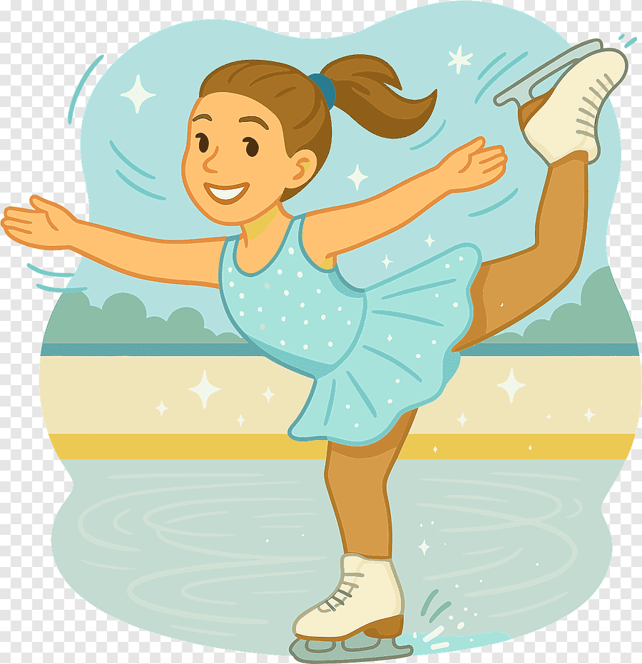

Skating Season

TFSC will offer a Fall session from September to December and a Winter session from January to March.

Fall 2026 Skating Schedule

Monday
4:00 - 4:50 Starskate 1
4:50 - 5:50 Starskate 2-3
6:00 - 6:30 Learn to Skate - Session A
6:00 - 6:50 Canskate - Session A
7:00 - 8:20 Star 4 - Gold

Thursday
4:00 - 4:45 PowerSkate
4:55 - 5:50 CanSkate Session B & Starskate 1
6:00 - 7:00 Starskate 2-3
7:00 - 7:30 Stroking
7:40 - 9:00 Star 4 - Gold

Saturday
12:15 - 1:00 Star 4 - Gold
1:00 - 1:30 Learn to Skate & Canskate Session C
1:40 - 2:25 Starskate 2-3
2:15 - 3:00 Starskate 1

The Winter 2027 schedule will be posted in December.
Schedule is subject to change at the discretion of the Tilbury Figure Skating Club

TFSC Policies and Code of Conduct
The Tilbury Figure Skating Club is committed to promoting the sport of skating in a safe, positive, and supportive environment. All members are expected to contribute to this atmosphere by adhering to the following policies and guidelines:
- All skaters must be members in good standing with Skate Canada.
- Ice surface doors must remain closed at all times.
- Foul or inappropriate language will not be tolerated on or off the ice.
- Skaters must treat Coaches, Program Assistants, Board members, Volunteers, and Arena Staff with respect at all times.
- Food, beverages, and gum are not permitted at ice level or on the boards.
- Loitering at the boards during sessions is not permitted.
- Skaters are expected to participate in warm-ups, group lessons, and off-ice activities as scheduled.
- Dance sessions are designated exclusively for dance instruction and practice.
- During group lessons, skaters must pay close attention and refrain from horseplay, tag, games, pushing, or other unsafe behaviour.
- Dressing rooms are to be used only for changing into and out of skates and must be left clean and orderly. Skaters should not remain in dressing rooms after a session has begun.
- Appropriate skating attire must be worn at all times. Jeans are not permitted on the ice.
- Any skater, coach, or Board member suspected of being under the influence of alcohol or drugs will not be permitted on the ice or arena premises.
- Members are encouraged to address concerns directly with the coach involved whenever possible. If a concern remains unresolved, it must be submitted in writing and signed for Board review.
- Changes to groups or levels require prior Board approval.
- Guest fees must be paid to the Club before participating in a session.
- Skaters and their families are encouraged to support Club fundraising activities.
- Only registered skaters, coaches, and Program Assistants are permitted on the ice surface.
- Skaters must exercise courtesy and remain aware of other skaters at all times. They should be prepared to yield the right-of-way and take appropriate action to avoid accidents and injuries.
- Skaters with outstanding registration or coaching fees will not be permitted to attempt Skate Canada tests.
- Registration fee refunds will be considered only within two weeks of the skater's first session.
- Refunds for medical reasons may be granted upon submission of a physician's note, provided the skater is unable to participate for a continuous period of at least 12 weeks.

TFSC Policy Changes and Club Operations
The Board of Directors of the Tilbury Figure Skating Club reserves the right to amend Club policies, rules, and regulations as necessary and in the best interests of the membership. Any approved changes will be communicated through the Club bulletin board, newsletters, social media, or other official Club communications. While every effort is made to deliver the programs, activities, and services outlined in this handbook, members should recognize that the Club is operated by volunteers. As such, certain activities may be subject to volunteer availability.


FUNDRAISING
Registration fees alone do not cover the full cost of operating our programs. Fundraising plays an important role in helping the Club provide a quality skating experience while keeping registration fees as affordable as possible. We appreciate the support and participation of all families throughout the season.

1. Bingos
Bingo revenue is one of the Club’s primary sources of funding and helps offset operating costs. Without this funding, registration fees would need to increase significantly. Our bingo events are held at: Power Play Gaming Centre - 446 Advance Blvd., Tecumseh, ON N8N 5G8.
Bingo assignments are scheduled quarterly and may consist of either one 2-hour shift or a double bingo (4-hour shift). The Club has dedicated Board Member Volunteers who work these events on a rotating basis. Bingo proceeds are pooled, and the Club receives funding based on the number of assigned bingo sessions completed each month.
Anyone who enjoys playing bingo is encouraged to support the Club by attending the Bingo on our assigned dates. Bingo schedules will be posted on TeamReach as they become available.

2. Winter Raffle
A mandatory $100 Winter Raffle fee will be added to each registration for the 2027 Winter Skating Session. This fee includes 20 raffle tickets with a total value of $100. Families may choose to keep the tickets or sell them to friends and family to recover the cost of participation. Notification will be provided when tickets are available for pickup at the TFSC table in the arena lobby during regular skating sessions. If the table is not staffed, please contact a Board member for assistance.
Completed ticket stubs must be returned by April 4, 2027. Any tickets with unreturned stubs will be ineligible for the draw. Prize winners will be announced live during the Tilbury Figure Skating Club Carnival on April 4, 2027, at approximately 3:30 p.m. at the Tilbury Arena.

3. Additional Fundraising Activities
Additional fundraising events may be organized throughout the season. Details will be shared through TeamReach, email communications, social media, and the Club bulletin board. Members are encouraged to watch for announcements and support these initiatives whenever possible.

Private Coaching Information
All CanSkate programs include group instruction delivered by NCCP-certified professional coaches. Skaters seeking additional individualized instruction may choose to arrange private coaching. Private and semi-private lessons are typically conducted during the skater's regular session. Skaters participating at the STAR 2-Gold level are required to have a private coach.

Selecting a Private Coach
Families are responsible for contacting coaches directly to inquire about private lessons. A list of club coaches and their contact information is available in the club room. All arrangements for private or semi-private lessons are made directly between the skater's family and the coach. Lesson fees are billed by the coach and paid directly to them.
When selecting a coach, families should consider:
- Availability: Does the coach have lesson time available during the desired session?
- Skating Goals: Can the coach support the skater's objectives, and what lesson frequency is recommended?
- Coaching Fees: What are the costs for lessons, competitions, music editing, and other services?
- Coaching Philosophy: Does the coach's approach align with the skater's goals and expectations regarding testing, competitions, and development?
- Compatibility: A positive coach-skater relationship is important, as these partnerships are often long term.
To secure lesson availability, families are encouraged to book well in advance and confirm their intentions if returning for a future season.

Procedures for Changing a Private Coach
According to Skate Canada guidelines, once a skater enters into an agreement with a professional coach, that coach becomes the skater's Base Coach. The Base Coach works with the skater and family to develop training plans and make skating-related decisions. They are also responsible for informing the family of any additional coaches involved in the skater's development and the roles those coaches will play. Private coaching arrangements are contractual agreements between the skater's family and the coach. The TFSC Board of Directors does not intervene in coaching disputes or employment matters.
If you decide to change your skater's Base Coach, the following process must be followed:
- Notify your current Base Coach that you are terminating the coaching agreement.
- Do not engage a new coach until your current coach has been informed of your decision. Failure to do so may create concerns regarding coach solicitation.
- Settle all outstanding accounts with your current Base Coach.
- Research and contact prospective coaches for your skater.
- Before accepting a new coaching agreement, the prospective Base Coach may contact the previous coach to confirm that all outstanding fees have been paid.
Following this process helps ensure a professional and respectful transition for all parties involved.

Parent Information for Skaters Beyond the CanSkate Level
Parents who are considering private coaching for their child in addition to group lessons should note the following:
- Private lessons are generally not recommended during scheduled group instruction, as this results in paying for both group and private coaching at the same time.
- The frequency, scheduling, and fees for private lessons are determined directly between the parent and the coach. These arrangements are the responsibility of the family and coach, not the Club.
- It is recommended that skaters in the STAR 1-Gold program work with a private coach to support their ongoing development and progression.

Competitions
Competitions are open to all Skate Canada members. Skaters interested in competitive opportunities are strongly encouraged to work with a private coach. TFSC members may participate in competitions hosted by skating clubs throughout Southwestern Ontario. Entry fees apply, and additional expenses may include coaching fees, travel, accommodation, and related costs.
Before registering, consult your private coach to determine which events are appropriate and for which your skater is eligible. As competition registrations are completed online, your coach can also help ensure that all required information is submitted accurately.
For a complete list of sanctioned competitions, please visit Skate Ontario at www.skateontario.org.

Evaluation and Test Days
With the new evaluation system, skaters who were previously testing at the Preliminary and Junior Bronze levels are now assessed within STAR 1-5. Evaluations are conducted throughout the season by the skater's private coach or a qualified club coach during regular skating sessions. A $16.00 Skate Canada evaluation fee must be paid in advance, in addition to the coach's evaluation fee. Coaches will notify skaters and families when they are ready to be evaluated.
Skaters working toward Senior Bronze to Gold will be evaluated by Skate Canada-appointed evaluators on scheduled test days. A $25.00 Skate Canada test fee must be paid in advance, in addition to the coach's testing fee. These test days are governed by Skate Ontario and will be scheduled and announced as required.
Test applications must be submitted at least one month before the scheduled test day. Tests may be withdrawn up to two weeks prior to the test date.
Important Test Day Information
- Final test lists must be submitted 14 days before the test date.
- Test fees must be received 14 days before the test date.
- Test schedules will be posted on the figure skating bulletin board.
- Proper skating attire is required.
- Skaters must arrive at the arena and be ready to skate at least 30 minutes before their scheduled test time.
- Missed warm-up sessions will not be rescheduled.
JINGLE SHOWCASE
The Jingle Showcase is a fundraising event that provides skaters with the opportunity to showcase their skills in a fun and interactive environment. This is a fun event for our skaters to work individually and as a team; skaters must pay a fee to participate. This is a FREE event for spectators but there will be opportunities for the public to make donations (Raffle Tickets, donation of prizes, etc) and support our skating club. It is a great team-building event for our skaters and a whole lot of fun for them too.
The 2026 Jingle Showcase will take place on December 17, 2026

CARNIVAL GUIDELINES
The Carnival is held at the end of the skating season to celebrate and showcase the achievements of our skaters. The 2027 Carnival will take place on Sunday, April 4, 2027. Additional information will be shared through email, social media, and the club website.
The following guidelines apply:
- All costumes remain the property of the club and must not be taken home unless directed by the Carnival Chairperson.
- Skaters must be registered as full-time members to participate in the annual ice show.
- Skaters who miss three consecutive carnival practices will be removed from all ice show numbers.

CanSkate, Learn to Skate, and PowerSkaters
- Skaters will participate in one group number, organized and choreographed by the Professional Coaches and Carnival Chairperson.

STARSKATE 1 Skaters
- Full-time TFSC members will participate in two group numbers.

STARSKATE 2-3 Skaters
- Full-time TFSC members will participate in a minimum of two group numbers.
STARSKATE 4-Gold Skaters will participate in the opening group performance and they are eligible for a feature in this year's ice show if they meet the following criteria:
Solo Guidelines - A full paid member of the TFSC who has achieved at least one of the 3 criteria below:
- Successfully completed Star 4 Freeskate, Star 5 Skills, and Star 6 Dances.
- Earned a Gold Test.
- A Grade 12 graduate.
Feature Guidelines - A full paid member of the TFSC grouped with 2 or 3 skaters
Groups Guidelines - There will be 2 group numbers made up of skaters at the discretion of the carnival chairperson and coach.
Please remember that participation in a feature is a privilege earned through dedication and achievement, not a guaranteed entitlement.

Note: Costumes, headpieces, music, and choreography are all designed with the theme of the carnival in mind by the Carnival Chairperson and coaches to align with the carnival theme. To participate in the carnival, all skaters must wear their complete costume as intended to participate in the carnival. .

